

GmbH

Wiemecker Feld 14
59909 Bestwig
Germany

Phone: +49 (2904) – 711 60-0
Fax: +49 (2904) – 711 60-29
E-Mail: info@led-schmelter.de
Web: www.led-schmelter.de

Ladenbeleuchtung Phasenstrahler
3-Phasenstrahler (ab Lager, Großmengen kurzfristig lieferbar)
Wir haben ca. 570 Version an PUNCTIS 3-Phasen und
1-Phasen Strahlern so wie Magnetstrahler dauerhaft am Lager.
Diese Leuchten zeichen sich durch flexible Anbringung so
wie Langlebigkeit aus. Die verschiedensten Abstrahlwinkel,
Farben und Designs macht es möglich für individuell die
beste Auswahl zu treffen.

Code | Bild | Maße  mm | Watt | Farb-  versionen | Dimmbar | Lm | CRI | EEK A->G | Abstrahl-winkel
21089-S | 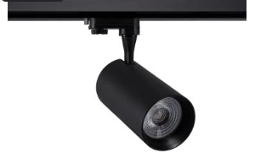 | 260 x Ø94 | 40W  UGR 21 | 3000K  4000K  5000KI | nein | 3200 | 90 | E | 36°
61098-W | 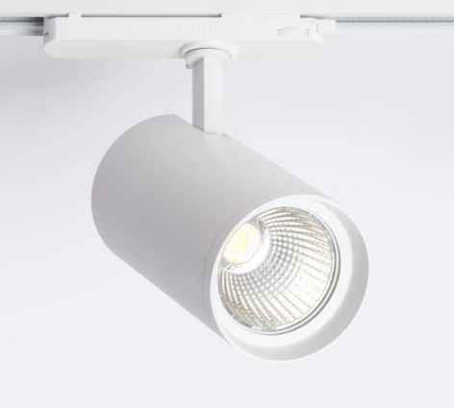 | 260 x Ø94 | 40W  UGR 21 | 3000K  4000K  5000KI | nein | 3200 | 90 | E | 36°
07607-S | 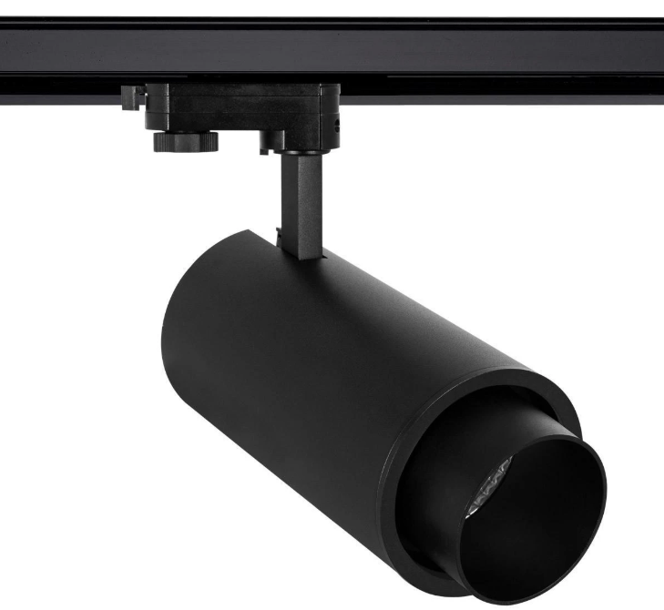 | 250 x Ø94 | 40W  UGR 21 | CCT  2700K  4000K  5000KI | nein | 4000 | 90 | E | 38°
90236-W | 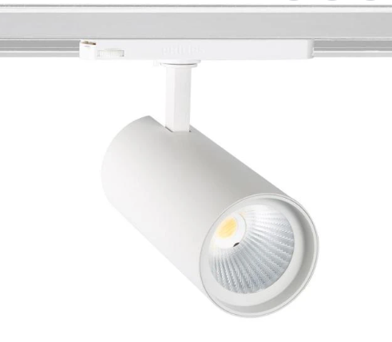 | 250 x Ø94 | 40W  UGR 21 | CCT  2700K  4000K  5000KI | nein | 4000 | 90 | E | 38°
47607-S | 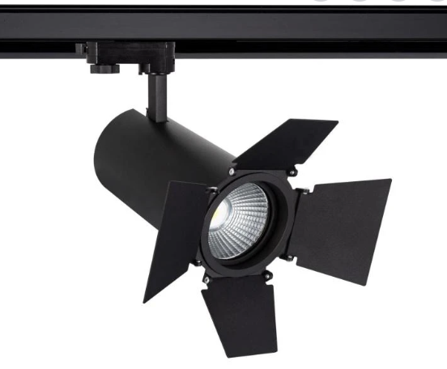 | 250 x Ø94 | 40W  UGR 21 | CCT  2700K  4000K  5000KI | nein | 4000 | 90 | E | 38°
924301-S | 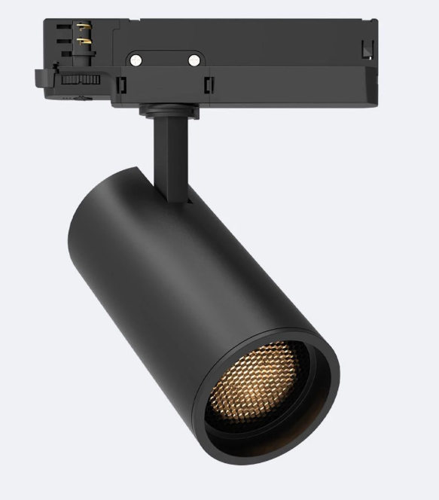 | 210 x Ø85 | 40W  UGR 17 | 2700K  3200K  4000K | ja  Triac | 4050 | 90 | E | 36°
21399-W | 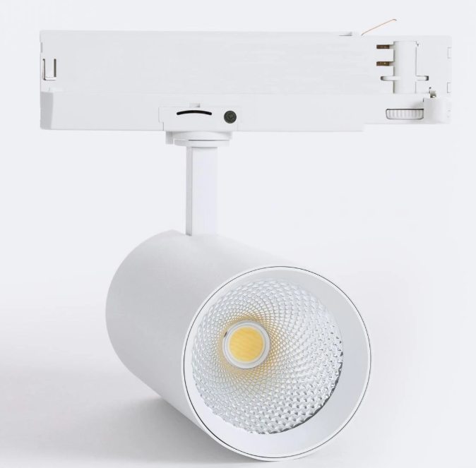 | 180 x Ø80 | 40W UGR 21 | CCT  2700K  3000K  400K | nein | 4800 |  | F | 36°
00299-W | 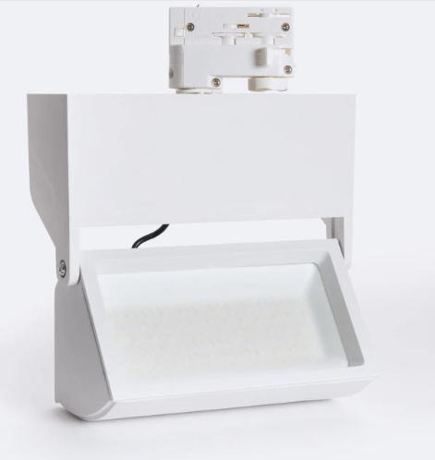 | 180/212  /110 | 40W  UGR 21 | 2700K  3500K  4000K  5000K  6000K | nein | 4300 | 80 | D | 100°
03187 | 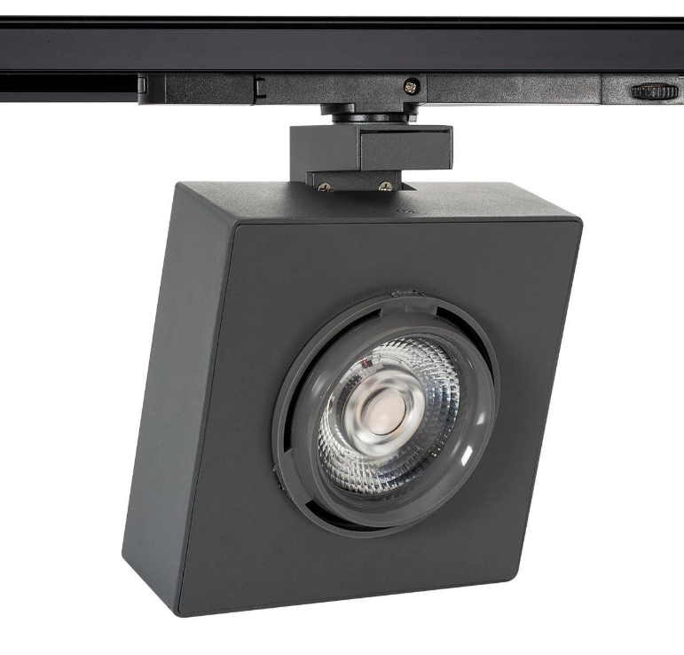 | 205/140  /140 | 40W  UGR 17 | 4000K | nein | 3150 | 85 | E | 40°

Code | Bild | Maße  mm | Watt | Farb-  versionen |  | Dimmbar | Lm | CRI |  | EEK A->G | Abstrahl-winkel
06136-S |  | Ø90  /160/210 | 30W  UGR 21 | 3000K  4000K |  | nein | 3000 | 80 |  | F | 24°
06136-W | 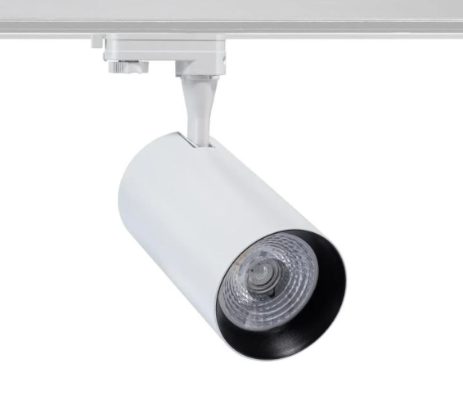 | Ø90  /160/210 | 30W  UGR21 | 3000K  4000K  5000K |  | nein | 3000 | 80 |  | F | 24°
8683-B | 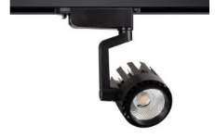 | Kopf:  110 x Ø100 | 30W  UGR 21 | 3000K  4000K  5000K |  | nein | 3000 | 80 |  | E | 36°
8683-W | 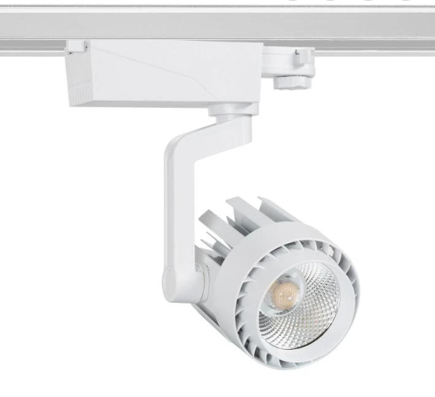 | Kopf:  110 x Ø100 | 30W  UGR 21 | 3000K  4000K |  | nein | 3000 | 80 |  | E | 36°
80456-S | 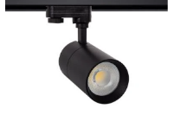 | Kopf  223 x  Ø76 | 30W  UGR 15 | 3000K  4000K  5000K |  | ja  Triac | 3000 | 80 |  | E | 36°
80456-W | 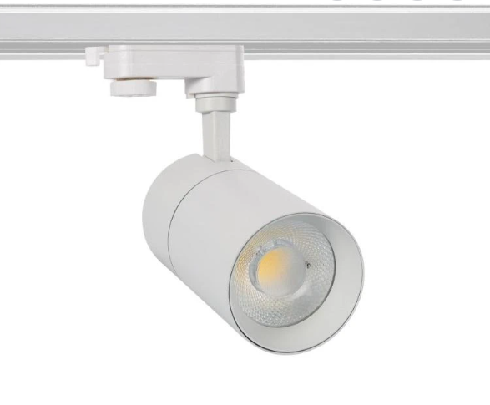 | Kopf  223 x  Ø76 | 30W  UGR 15 | 3000K  4000K  5000K |  | ja  Triac | 3000 | 80 |  | E | 36°
120410-S | 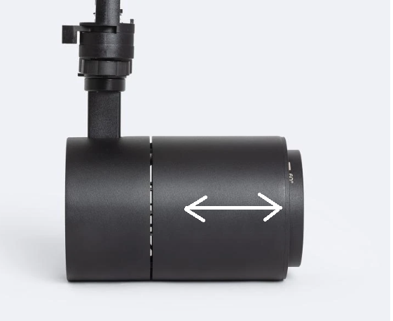 | Ø88  /153/147 | 30W  UGR 15 | CCT  2700-3600-4500K |  | ja  Triac | 3000 | 90 |  | E | 24°-60°  Linse
120410-W | 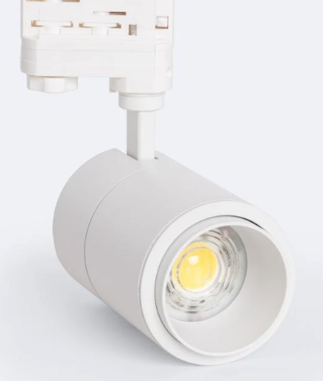 | Ø88  /153/147 | 30W  UGR 15 | CCT  2700-3600-4500K |  | ja  Triac | 3000 | 90 |  | E | 24°-60°  Linse
73099-S | 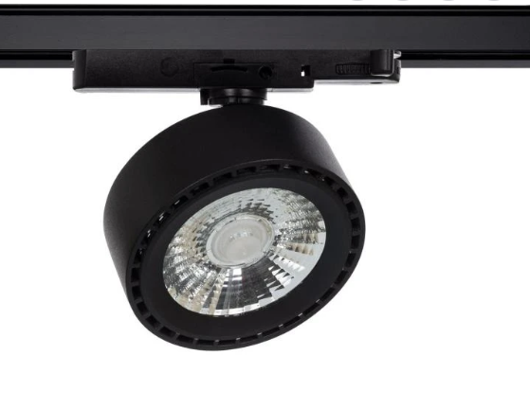 | 43/115/165 | 30W  UGR 16 | CCT  3000-4000-  6000K |  | nein | 4000 | 90 |  | F | 30°
73099-W | 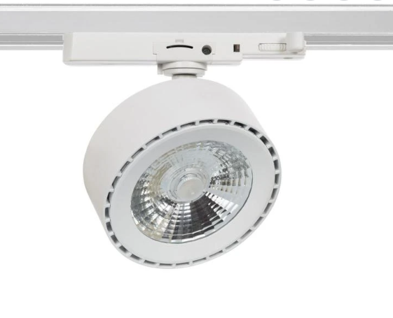 | 43/115/165 | 30W  UGR 16 | CCT  3000-4000-  6000K |  | nein | 4000 | 90 |  | F | 30°
537501-B | 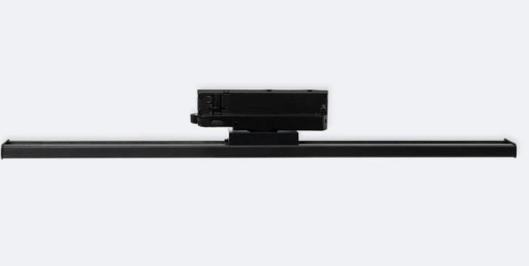 | 45/600/75 | 30W  UGR17 | CCT  2700-  4000K |  | ja  Triac | 2700 | 80 |  | F | 120°
537501-W | 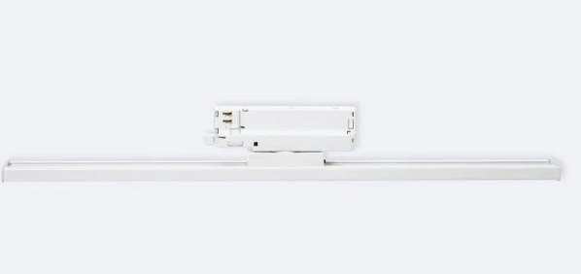 | 45/600/75 | 30W  UGR17 | CCT  2700-  4000K |  | ja  Triac | 2700 | 80 |  | F | 120°
72187-S | 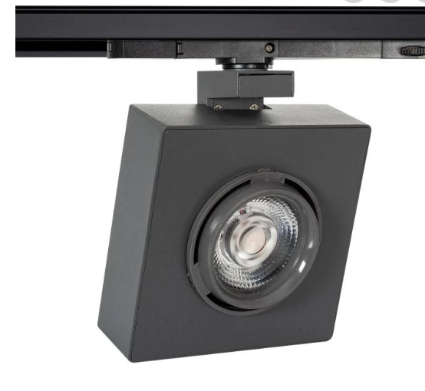 | 205/140/140 | 30W  UGR17 | 4000K |  | nein | 2550 | 85 |  | F | 40°
Code | Bild | Maße  mm | Watt | Farb-  versionen |  | Dimmbar | Lm | CRI |  | EEK A->G | Abstrahl-winkel
21868-S | 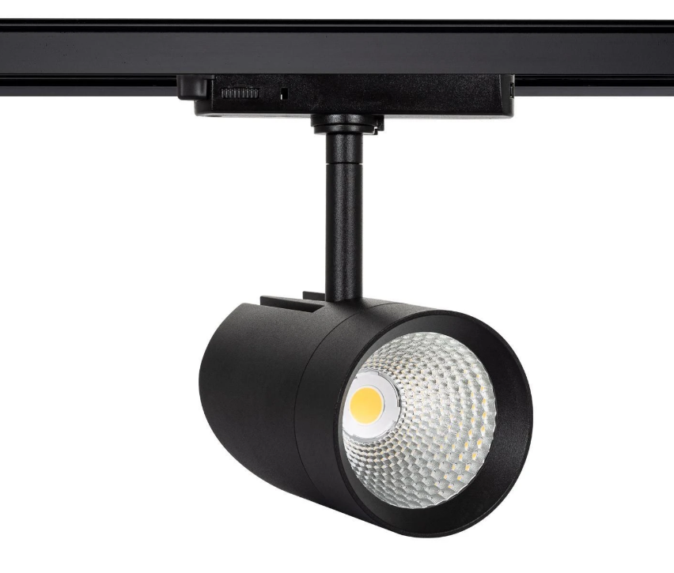 | 225/90/135 | 30W  UGR21 | 4000K |  | nein | 2550 | 90 |  | F | 40°
60868-W | 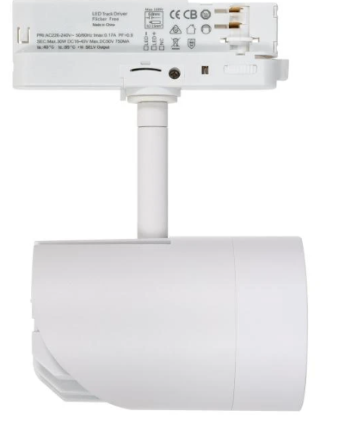 | 225/90/135 | 30W  UGR21 | 4000K |  | nein | 2550 | 90 |  | F | 40°
159511 | 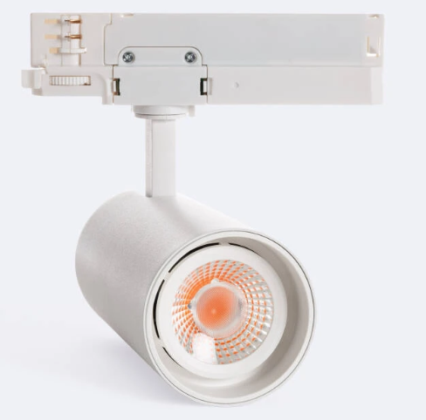 | 215 x Ø75 | 30W  UGR21 | 1800K  Metzgerei-strahler |  | nein | 2300 | 90 |  | F | 40°
Code | Bild | Maße  mm | Watt | Farb-  versionen |  | Dimmbar | Lm | CRI |  | EEK A->G | Abstrahl-winkel
427601-B | 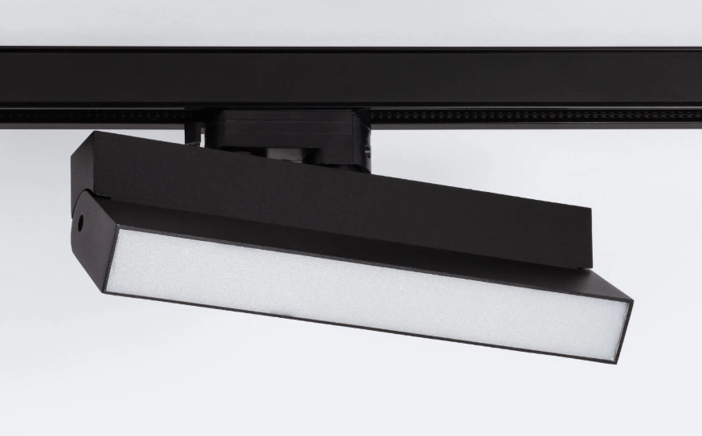 | 35/165/270 | 24W  UGR21 | CCT  3000-4000-  5000K |  | ja  Triac | 2400 | 80 |  | F | 120°
427601-W | 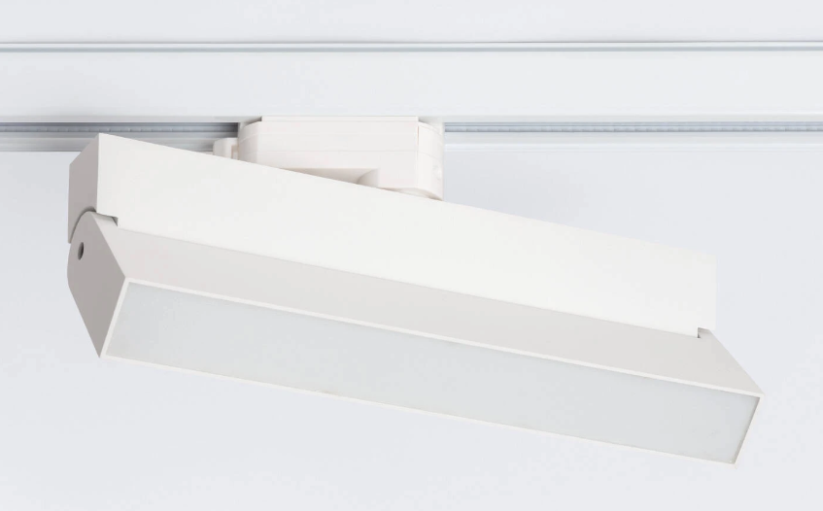 | 35/165/270 | 24W  UGR21 | CCT  3000-4000-  5000K |  | ja  Triac | 2400 | 80 |  | F | 120°
Code | Bild | Maße  mm | Watt | Farb-  versionen |  | Dimmbar | Lm | CRI |  | EEK A->G | Abstrahl-winkel
15456-S |  | Kopf  240xØ87 | 20W  UGR 15 | CCT  3000-4000-6000K |  | Ja  Triac | 2000 | 80 |  | E | 36°
11456-W | 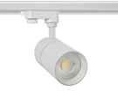 | Kopf  240xØ87 | 20W  UGR 15 | CCT  3000-4000-6000K |  | Ja  Triac | 2000 | 80 |  | E | 36°
63399-S | 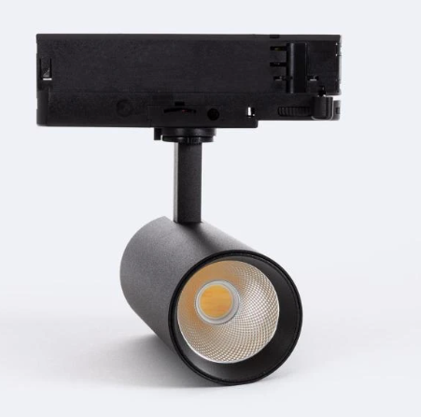 | Kopf  160xØ60 | 20W  30W  40W  UGR 19 | 2700K  3500K  4000K  4000K  5000K  6000K |  | Nein | 2400 | 80 |  | F | 36°
56299-W  +  43399-S | 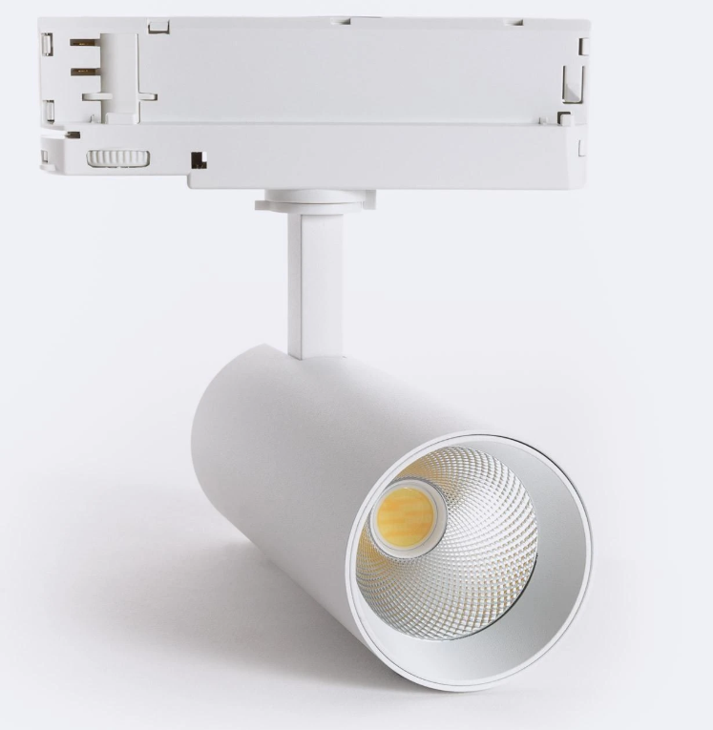 | Kopf  160xØ60 | 20W  UGR 19 | 2700K  3500K  4000K  5000K  6000K |  | Nein | 2400 | 90 |  | F | 36°
Code | Bild | Maße  mm | Watt | Farb-  versionen |  | Dimmbar | Lm | CRI |  | EEK A->G | Abstrahl-winkel
23099-S | 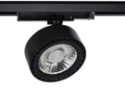 | 43/115/165 | 20W  UGR 16 | CCT  3000-4000-  6000K |  | Nein | 2480 | 90 |  | F | 30°
72099-W | 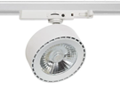 | 43/115/165  Ø97/35 | 20W  UGR 16 | CCT  3000-4000-  6000K |  | nein | 2480 | 90 |  | F | 30°
196801-S | 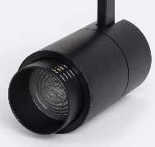 | Kopf  139 X Ø76 | 20W  UGR 15 | CCT  2700-3600-  4500K |  | Ja  Triac | 2000 | 80 |  | F | 15-60°
196801-W | 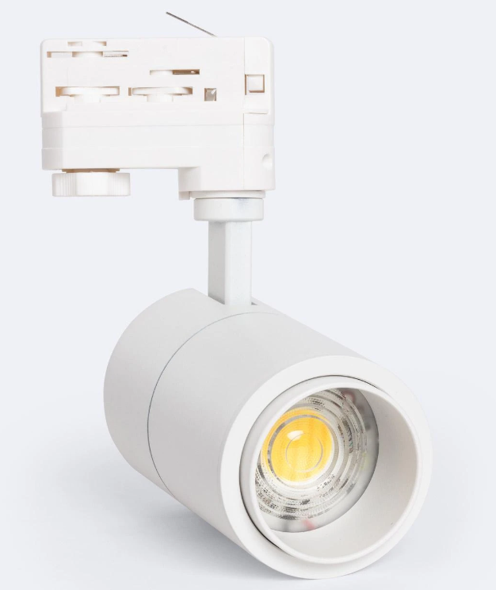 | Kopf  139 X Ø76 | 20W  UGR 15 | CCT  2700-3600-  4500K |  | Ja  Triac | 2000 | 80 |  | F | 15-60°
430301-B | 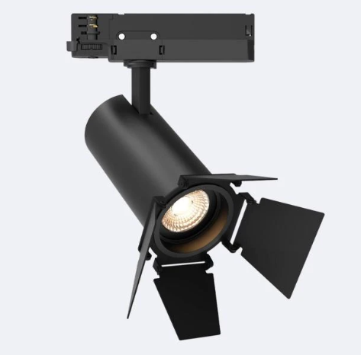 | 195 x Ø65 | 20W  UGR 21 | CCT  2700-3200-4000K |  | Ja  Triac | 1980 | 90 |  | F | 36°
430301-W | 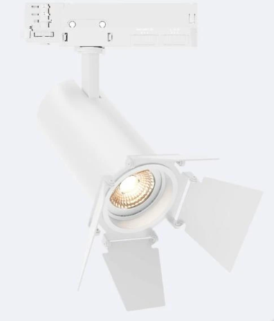 | 195 x Ø65 | 20W  UGR 21 | CCT  2700-3200-4000K |  | Ja  Triac | 1980 | 90 |  | F | 36°
Code | Bild | Maße  mm | Watt | Farb-  versionen |  | Dimmbar | Lm | CRI |  | EEK A->G | Abstrahl-winkel
915821-C | 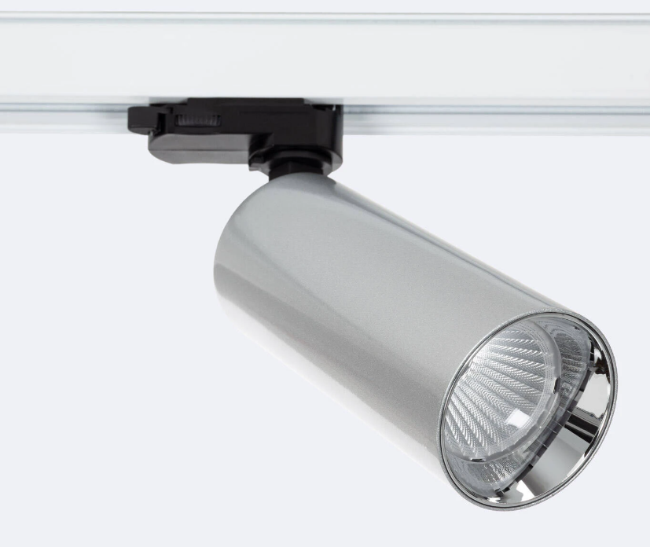 | 205/84,5  145xØ63 | 18W  UGR 19 | CCT  2700-4000-  6000K |  | nein | 1800 | 90 |  | F | 38°
915821-S | 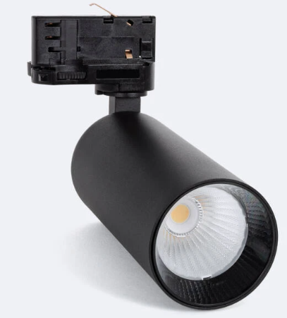 | 205/84,5  145xØ63 | 18W  UGR 19 | CCT  2700-4000-  6000K |  | nein | 1800 | 90 |  | F | 38°
915821-W | 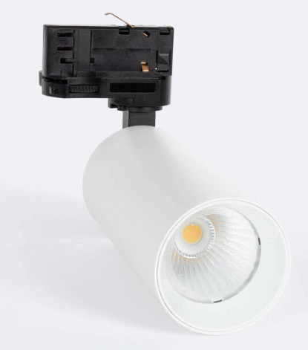 | 205/84,5  145xØ63 | 18W  UGR 19 | CCT  2700-4000-  6000K |  | nein | 1800 | 90 |  | F | 38°
8474-S | 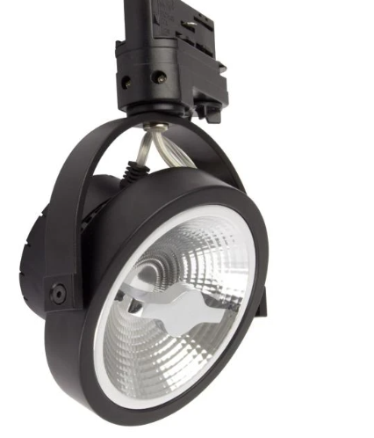 | 190/190/Ø210 | 15W  Cree  AR111 | 2700K  4000K  5000K |  | Ja  Triac | 800 | 80 |  | F | 24°
7474-W | 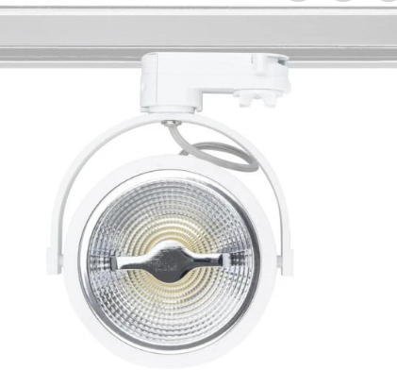 | 190/190/Ø210 | 15W  Cree  AR111 | 2700K  4000K  5000K |  | Ja  Triac | 800 | 80 |  | F | 24°
007601-S | 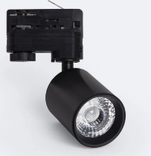 | 80/120/55 | 10W  UGR 15 | 3000K  4000K |  | Ja  Triac | 1000 | 80 |  | G | 15°
007601-W | 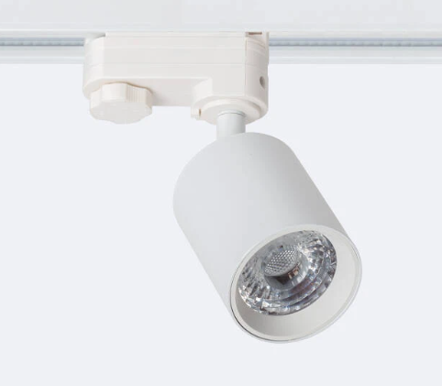 | 80/120/55 | 10W  UGR 15 | 3000K  4000K |  | Ja  Triac | 1000 | 80 |  | G | 15°
786801-S | 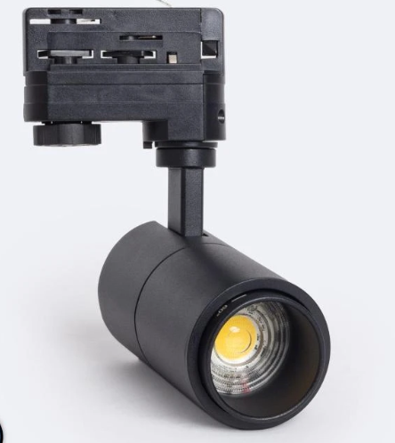 | 60/131/120 | 10W  UGR 15 | CCT  3000-4000-6000K |  | Ja  Triac | 1000 | 80 |  | F | 15°-60°  Linse
786801-W | 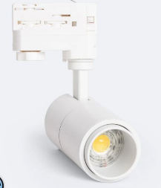 | 60/131/120 | 10W  UGR 15 | CCT  3000-4000-6000K |  | Ja  Triac | 1000 | 80 |  | F | 15°-60°  Linse
Code | Bild | Maße  mm | Watt | Farb-  versionen |  | Dimmbar | Lm | CRI |  | EEK A->G | Abstrahl-winkel
215821-S | 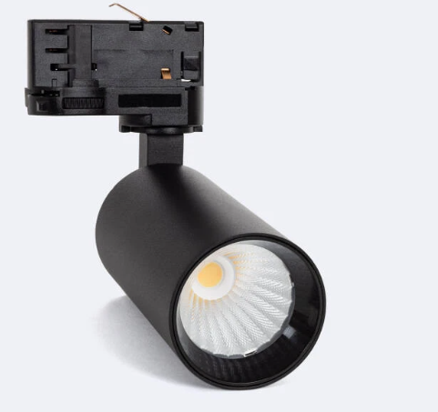 | Kopf  110 x Ø55 | 9W  UGR 19 | CCT  3000-4000-6000K |  | nein | 900 | 90 |  | F | 38°
215821-C | 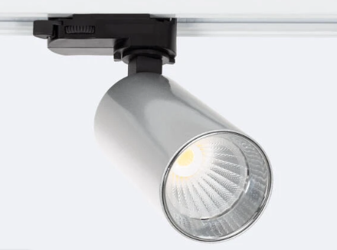 | Kopf  110 x Ø55 | 9W  UGR 19 | CCT  3000-4000-6000K |  | nein | 900 | 90 |  | F | 38°
215821-W | 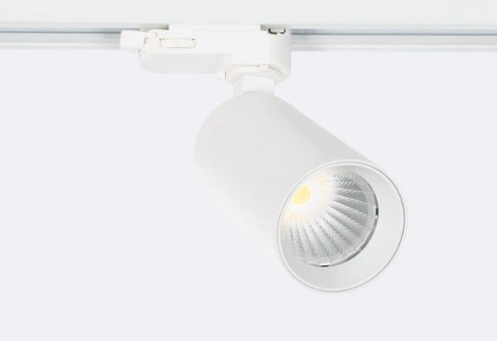 | Kopf  110 x Ø55 | 9W  UGR 19 | CCT  3000-4000-6000K |  | nein | 900 | 90 |  | F | 38°
 | 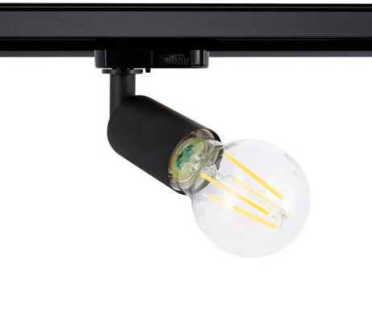 | 142 / 70 | E27  Max. 25W | ./. |  | ./. | ./. | ./. |  | ./. | ./.
 | 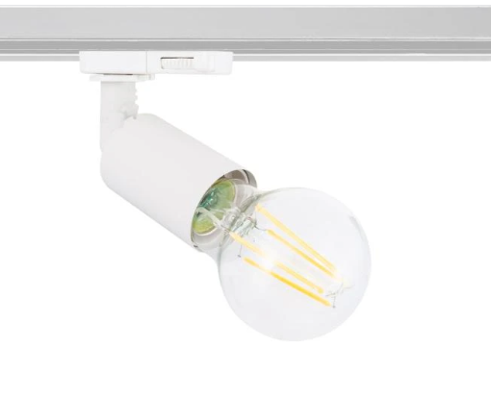 | 142 / 70 | E27  Max. 25W | ./. |  | ./. | ./. | ./. |  | ./. | ./.
89773-S | 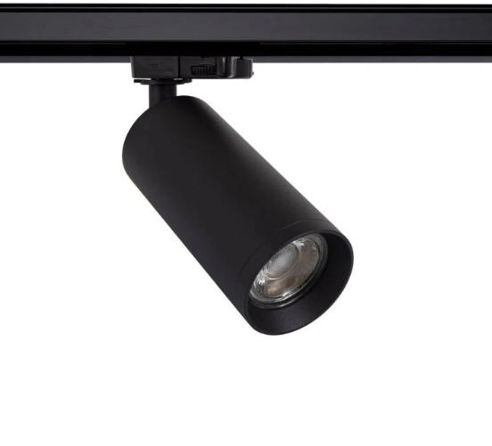 | 215 / 60 | GU10  Max.  10W | ./. |  | ./. | ./. | ./. |  | ./. | ./.
89773-W | 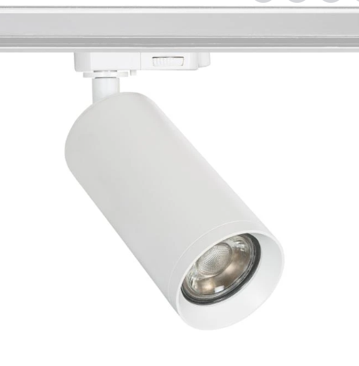 | 215 / 60 | GU10  Max.  10W | ./. |  | ./. | ./. | ./. |  | ./. | ./.
89773-G | 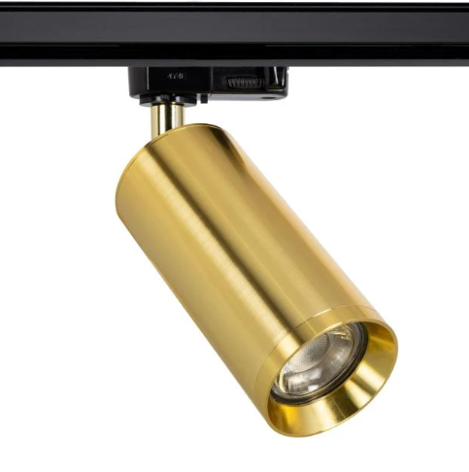 | 215 / 60 | GU10  Max.  10W | ./. |  | ./. | ./. | ./. |  | ./. | ./.
89773-C | 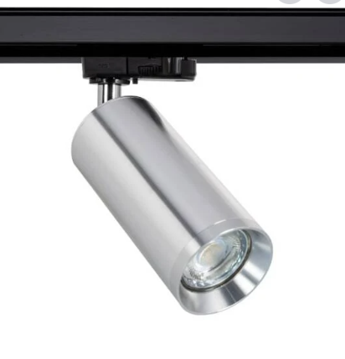 | 215 / 60 | GU10  Max.  10W | ./. |  | ./. | ./. | ./. |  | ./. | ./.
Code | Bild | Maße  mm | Watt | Farb-  versionen |  | Dimmbar | Lm | CRI |  | EEK A->G | Abstrahl-winkel
92107-S | 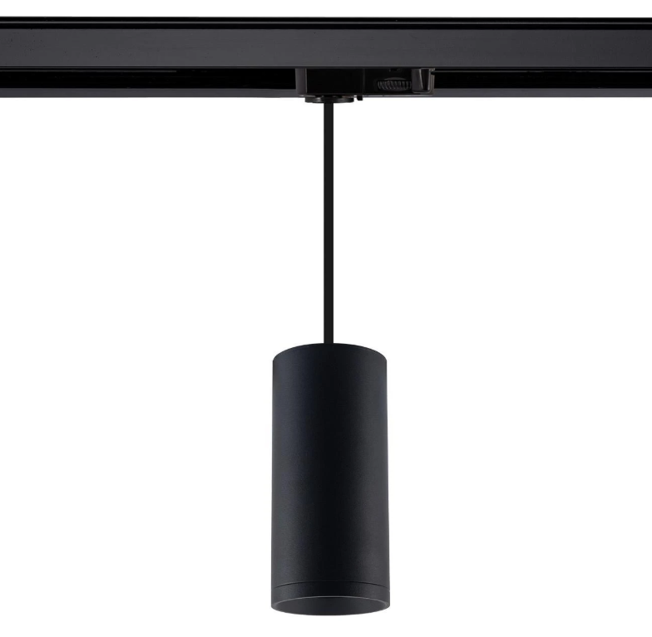 | 130 / Ø55 | GU10  Max.  10W | ./. |  | ./. | ./. |  |  | ./. | ./.
92107-W | 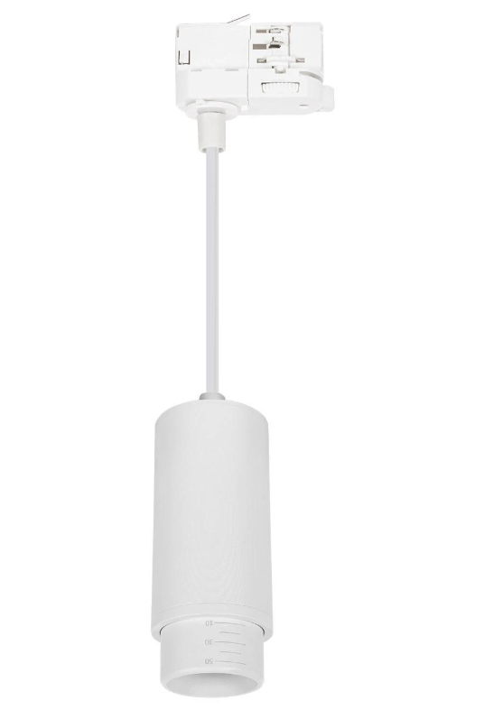 | 130 / Ø55 | GU10  Max.  10W | ./. |  | ./. | ./. |  |  | ./. | Multi-winkel
S-TLST-1S  S-TLST-2S | 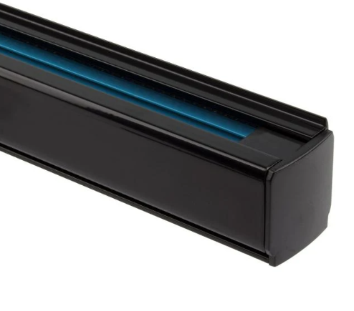 | 1m  2m  /32,2 / 36,4 | Max.  2000W  10A | ./.  ./. |  | ./.  ./. | ./.  ./. |  |  | ./.  ./. | ./.  ./.
S-3PH-1W  S-3PH-2W | 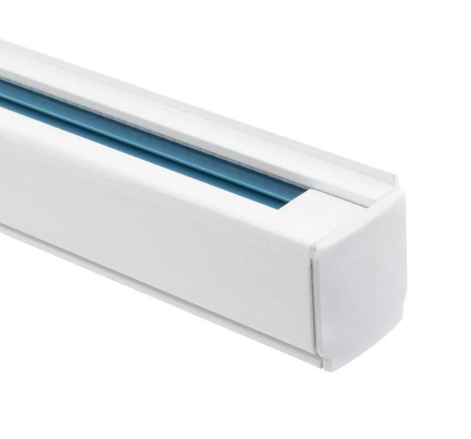 | 1m  2m  /32,2 / 36,4 | Max.  2000W  10A | ./.  ./. |  | ./.  ./. | ./.  ./. |  |  | ./.  ./. | ./.  ./.
 | 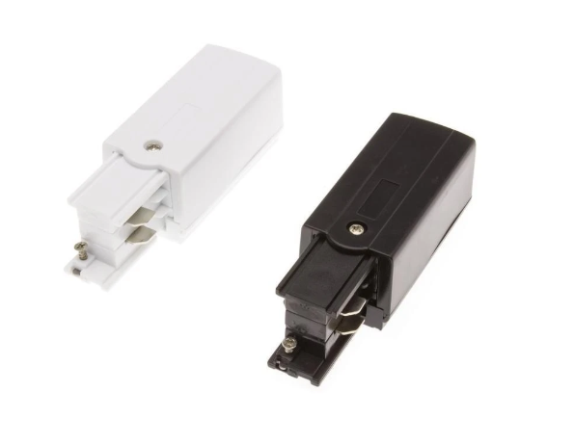 | 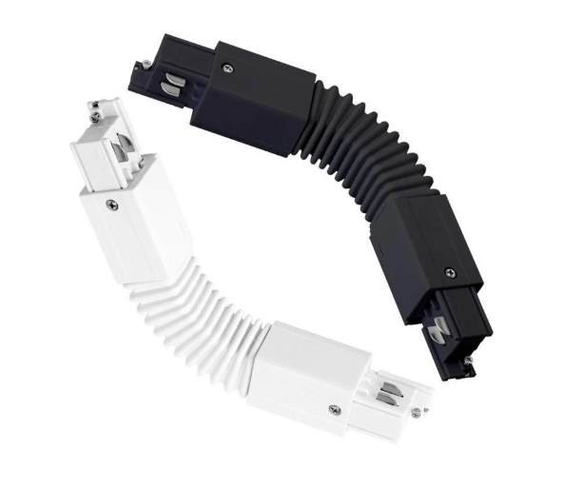 | 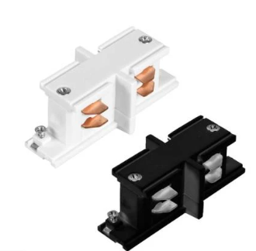 |  | 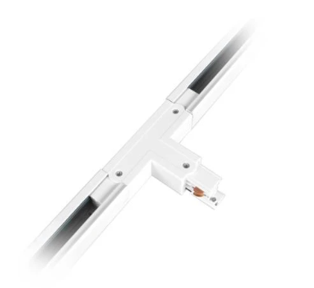 | 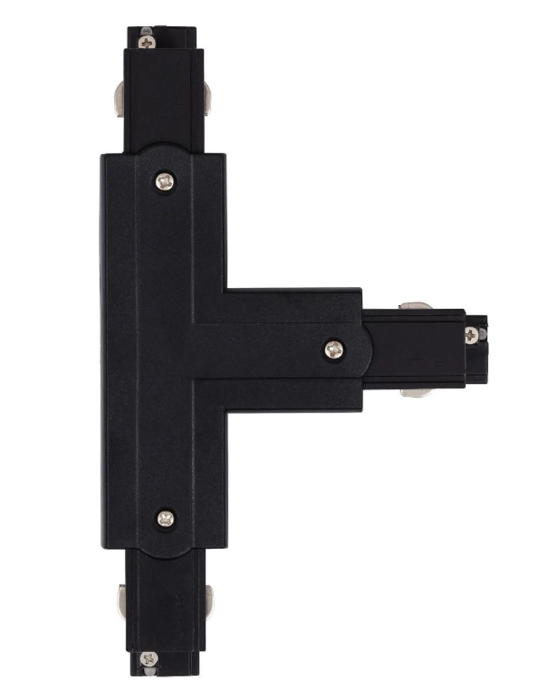 | 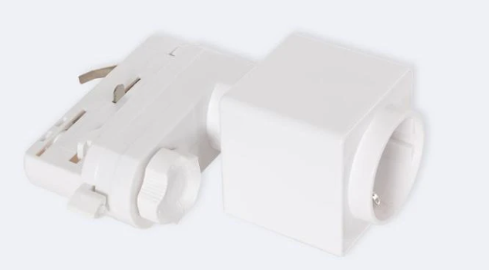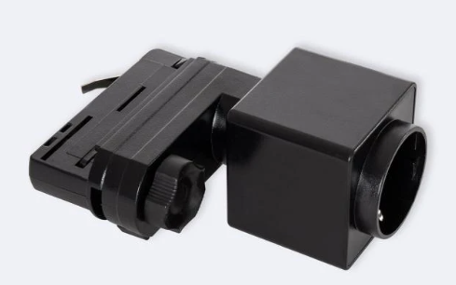 |  | 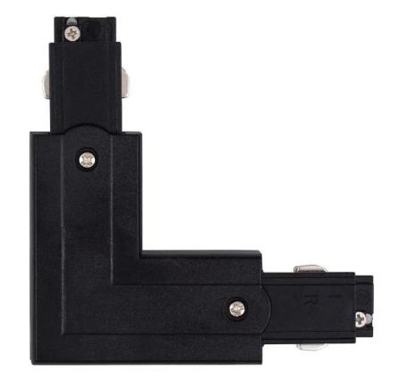  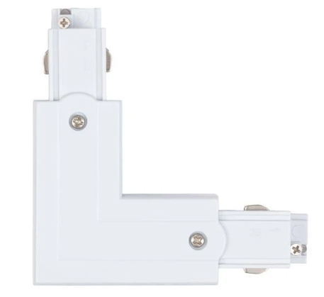 |  | 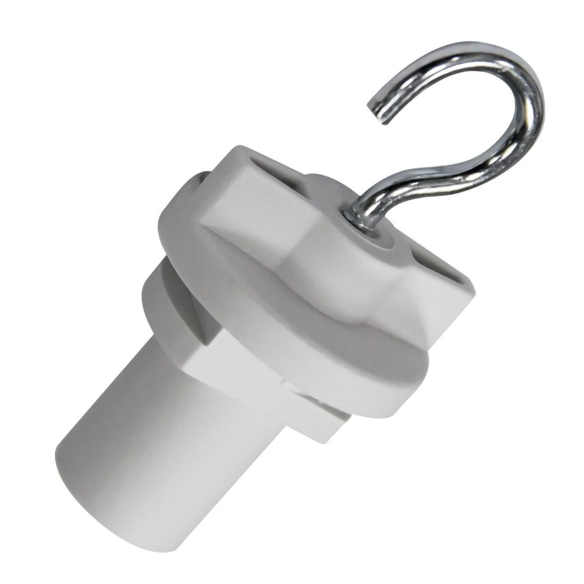
 | Anschluss  Eingang RE | Verbinder Flex | Verbinder  Fix |  | T-Stück RE | T-Stück  LI | Steckdose |  | L-RE  Stück |  | Hänger
Code | 5081-079 | 5213-4291 | 8971-169 |  | 0081 | 8202 | 625401 |  | 1871-469 |  | 12841
Preis €/Stk.EXW | 3,77 | 10,92 | 5,20 |  | 8,73 | 8,73 | 16,38 |  | 6,55 |  | 1,59

